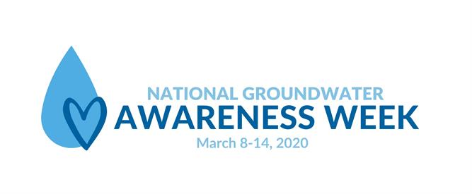
National Groundwater Awareness Week is an annual, weeklong observance established by the National Ground Water Association in 1999, to highlight the responsible development, management, and use of water. Did you know that groundwater is the world’s most extracted raw material? An estimated range of 259 trillion gallons of groundwater is extracted each year!

If you are a Story County private well owner or user, springtime is a great time to test your well water, tend to your well water system, and treat your well if necessary. Annual well water testing for bacteria and nitrates is recommended especially during the springtime, when groundwater levels are at their highest elevations.

Why test? Because the taste, smell, or visual appearance of your well water will not necessarily allow you to detect contamination. Under Story County’s Grants-To-County Program, our residents are able to have their well water tested for Coliform bacteria, nitrate, and arsenic concentrations annually for FREE!

Our grant also allows us to assist county residents with the cost of plugging an abandoned well, renovating an existing well, or filling in of a cistern. The grant reimburses up to $500 toward a well plugging, up to $1000 toward a well renovation, and up to $300 for a cistern elimination.

Having your well water tested and well system cared for annually is the smart thing to do to protect the health of you and your family. Please contact:

Story County Environmental Health Department
Healthweb@storycountyiowa.gov
515-382-7240
to set up an appointment today!

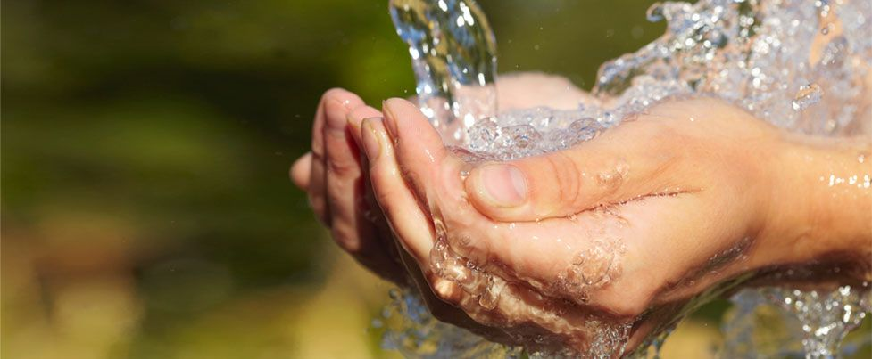
Groundwater: It’s the water we drink

